5 Marks Questions
Q.1. What are the issues in machine Learning?
Q.2. Explain Logistic regression.
Logistic regression is a supervised machine learning algorithm used for classification problems. It predicts the probability that an input belongs to a specific class, unlike linear regression which forecasts a continuous numerical output. This probability can then be used to classify data
Logistic regression is a statistical model used primarily for binary classification tasks, despite its name containing "regression." It predicts the probability of a binary outcome (e.g., yes/no, 0/1, true/false) based on one or more independent variables.
Key Concepts:
- Binary Outcome:
The dependent variable in logistic regression can only take on two possible values, representing the presence or absence of an event.
- Sigmoid Function (Logistic Function):
Unlike linear regression which predicts a continuous output, logistic regression uses the sigmoid function to transform the linear combination of independent variables into a probability value between 0 and 1. The sigmoid function produces an "S"-shaped curve.
- Probability Interpretation:
The output of the logistic regression model is a probability. For example, a predicted value of 0.75 means there's a 75% chance of the event occurring.
- Classification Threshold:
To convert the predicted probability into a binary classification, a threshold is typically applied (e.g., if the probability is > 0.5, classify as 1; otherwise, classify as 0).
- Odds and Log-Odds:
Logistic regression models the log-odds of the outcome. The odds represent the ratio of the probability of an event occurring to the probability of it not occurring. The natural logarithm of the odds is called the log-odds or logit.
How it Works:
Logistic regression estimates the coefficients for each independent variable, similar to linear regression. These coefficients determine the impact of each variable on the log-odds of the outcome. The estimated log-odds are then transformed back into probabilities using the sigmoid function.

Types of logistic regression
- Binary Logistic Regression: For two outcomes.
- Multinomial Logistic Regression: For three or more unordered outcomes.
- Ordinal Logistic Regression: For three or more ordered outcomes.

Advantages
- Easy to implement and interpret.
- Effective on linearly separable data.
- Provides probabilities, offering insight into prediction confidence.

Disadvantages
- Assumes a linear relationship between independent variables and the log-odds of the dependent variable.
- Can overfit on high-dimensional data; regularization may help.
- Struggles with complex, non-linear relationships.
- Sensitive to outliers.

Q.3. Differentiate between Linear Regression and Logistic Regression.
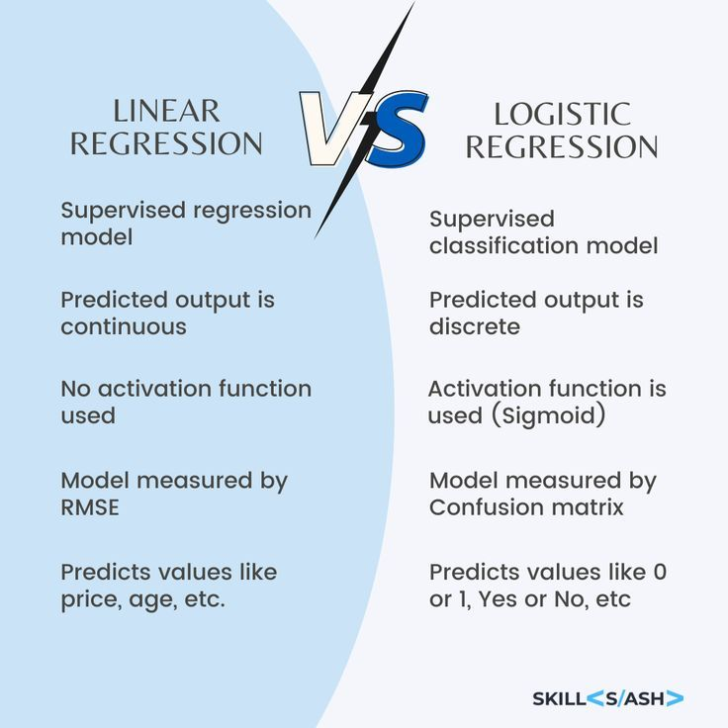

Q.4. Explain Multivariate Linear Regression.
Multivariate linear regression is a statistical method that examines the linear relationship between multiple dependent variables and multiple independent variables. It's a powerful tool for understanding how several factors collectively influence a set of outcomes. Essentially, it extends the concept of simple linear regression (one dependent, one independent) and multiple linear regression (one dependent, multiple independent) to encompass multiple outcomes simultaneously.
Here's a more detailed explanation:
- Multiple Dependent Variables:
Unlike simple or multiple linear regression, multivariate regression deals with more than one outcome or dependent variable. For example, you might be interested in predicting both sales revenue and customer satisfaction based on several marketing campaign variables.
- Multiple Independent Variables:
Similar to multiple regression, multivariate regression also involves multiple independent or predictor variables that are believed to influence the dependent variables.
- Linear Relationship:
The core assumption is that the relationship between the independent and dependent variables is linear, meaning it can be represented by a straight line (or hyperplane in higher dimensions).
- Goal:
The goal is to find a set of linear equations that best describes the relationships between the independent and dependent variables, allowing for predictions and understanding of how changes in the independent variables affect the dependent variables.
- Applications:
Multivariate regression is used in various fields, including economics, social sciences, and engineering, for tasks like predictive analysis, risk assessment, and process optimization.
In essence, multivariate linear regression provides a framework for analyzing complex relationships between multiple inputs and multiple outputs, offering insights that single or multiple linear regression might miss.

Q.5. Explain any five applications of Machine Learning.
Organizations use machine learning to automate tasks, make smarter decisions and gain valuable insights. ML is shaping the world around us. Here are few real-world applications of Machine Learning:

1. Healthcare and Medical Diagnosis
ML algorithms can analyze large volumes of patient data, medical scans and genetic information to aid in diagnosis and treatment.
Applications:
- Disease Detection: ML models are used to identify diseases like cancer, pneumonia and Parkinson’s from medical images. They often achieve accuracy comparable to or better than human doctors.
- Predictive Analytics: By analyzing patient history and symptoms, models can predict the risk of certain diseases or potential complications.
- Drug Discovery: ML accelerates the drug development process by predicting how different compounds will interact, reducing the time and cost of research.

2. Smart Assistants and Human-Machine Interaction
Virtual assistants systems rely on natural language processing (NLP) and speech recognition to understand commands and respond intelligently.
Applications:
- Voice Assistants: Tools like Siri, Alexa and Google Assistant convert spoken input into actionable commands.
- Voice Search & Transcription: ML enables users to perform hands-free web searches and get transcription during meetings or phone calls.
- Chatbots: Businesses use AI-powered chatbots for 24/7 customer support, helping resolve queries faster and more efficiently.

3. Personalized Recommendations and User Experience
Modern digital platforms uses personalization which is done by using recommender systems. Machine learning models analyze user behavior to deliver relevant content, improving engagement and satisfaction.
Applications:
- Streaming Platforms: Netflix and Spotify suggest shows and songs based on your watching or listening history.
- E-commerce: Sites like Amazon recommend products tailored to your preferences, browsing patterns and past purchases.
- Social Media: Algorithms curate content feeds, prioritize posts and suggest friends or pages.
These systems use techniques like collaborative filtering and content-based filtering to create personalized digital experiences.

4. Fraud Detection and Financial Forecasting
In finance, vast sums of money move digitally and machine learning plays a important role in fraud detection and market analysis.
Applications:
- Transaction Monitoring: Banks use ML models to detect unusual spending behavior and flag suspicious transactions.
- Loan Risk Assessment: Credit scoring models analyze customer profiles and predict the likelihood of default.
- Stock Market Prediction: ML is used to analyze historical stock data and forecast price movements. Stock markets are complex, algorithmic trading uses these predictions for better decision-making.
5. Autonomous Vehicles and Smart Mobility
Self-driving vehicles use ML to understand their environment, navigate safely and make immediate decisions.
Key Components:
- Computer Vision: Recognizing lanes, pedestrians, traffic signals and obstacles.
- Sensor Fusion: Combining data from cameras, LiDAR and radar for a 360-degree view.
- Behavior Prediction: Anticipating how other drivers or pedestrians may act.
Autonomous vehicles are capable of operating with minimal human input. Beyond cars, ML is also being used in traffic optimization, smart navigation systems and predictive maintenance in transportation.

Q.6. Explain Gini Index along with an example.
The Gini Index, also known as Gini impurity, is a metric used primarily in decision tree algorithms to measure the impurity or inequality of a node. It quantifies the probability of incorrectly classifying a randomly chosen element from a dataset if that element were labeled randomly according to the class distribution within the set.
The Gini Index ranges from 0 to 1:
- 0 (perfect purity/equality): All elements in the node belong to the same class.
- 1 (maximum impurity/inequality): Elements are perfectly distributed across all possible classes (e.g., in a binary classification, an equal split between two classes).
- 0.5 (for binary classification): Represents an equal distribution of elements into two classes.
Formula:
The Gini Index is calculated using the formula:
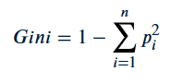
where:
- Pi is the probability of an element belonging to class i.
- n is the number of classes.
Example:
Consider a node in a decision tree that contains 10 data points, with 7 belonging to Class A and 3 belonging to Class B.
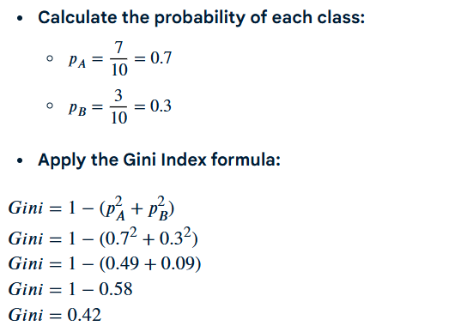
This Gini Index of 0.42 indicates a moderate level of impurity in the node. In decision tree construction, the algorithm aims to find splits that result in child nodes with lower Gini Index values, indicating increased purity and better classification.

Q.7. Explain how Supervised Learning is different from Unsupervised Learning.
Supervised Learning and Unsupervised Learning represent two fundamental approaches within machine learning, distinguished primarily by the nature of the data they utilize and their respective objectives.

Supervised Learning:
- Data Type:
Relies on labeled data, where each input instance in the training set is associated with a corresponding correct output or "label."
- Objective:
To learn a mapping function from inputs to outputs, enabling the model to accurately predict the output for new, unseen input data. This involves tasks such as classification (predicting a categorical label) and regression (predicting a continuous value).
- Process:
The algorithm learns by comparing its predictions to the known correct labels and adjusting its internal parameters to minimize prediction errors.

Unsupervised Learning:
- Data Type:
Operates on unlabeled data, meaning the training data lacks predefined output labels or target variables.
- Objective:
To discover hidden patterns, structures, or relationships within the data without any prior knowledge of the desired output. This often involves tasks like clustering (grouping similar data points) and dimensionality reduction.
- Process:
The algorithm identifies inherent patterns or structures within the data independently, often by analyzing similarities or dissimilarities between data points. There is no external feedback on the "correctness" of the patterns identified.

Key Distinctions Summarized:
- Data:
Supervised learning uses labeled data; Unsupervised learning uses unlabeled data.
- Goal:
Supervised learning aims to predict outcomes; Unsupervised learning aims to discover patterns.
- Feedback:
Supervised learning receives explicit feedback (correct labels); Unsupervised learning operates without explicit feedback on correctness.
- Common Tasks:
Supervised learning includes classification and regression; Unsupervised learning includes clustering and dimensionality reduction.

Q.8. How to choose right Machine Learning algorithm?
Here is a step-by-step procedure to choose correct machine learning algorithm :
- Understand Your Problem : Begin by gaining a deep understanding on the problem you are trying to solve. What is your goal? What is the problem all about classification, regression , clustering, or something else? What kind of data you are working with?
- Process the Data: Ensure that your data is in the right format for your chosen algorithm. Process and prepare your data by cleaning, Clustering, Regression.
- Exploration of Data: Conduct data analysis to gain insights into your data. Visualizations and statistics helps you to understand the relationships within your data.
- Metrics Evaluation: Decide on the metrics that will measure the success of model. You must choose the metric that should align with your problem.
- Simple models: One should begin with the simple easy-to-learn algorithms. For classification, try regression, decision tree. Simple model provides a baseline for comparison.
- Use Multiple Algorithms: Try to use multiple algorithms to check that one performs on your dataset. That may include:
  - Decision Trees
  - Gradient Boosting(XGBoost, LightGBM)
  - Random Forest
  - k-Neasrest Neighbors(KNN)
  - Naive Bayes
  - Support Vector Machines(SVM)
  - Neural Networks(Deep Learning)
- Hyperparameter Tuning: Grid Search and Random Search can helps with adjusting parameters choose algorithm that find best combination.
- Cross- Validation: Use cross- validation to get assess the performance of your models. This helps prevent overfiting .
- Comparing Results: Evaluate the models's performance by using the metrics evaluation. Compare their performance and choose that best one that align with problem's goal.
- Consider Model Complexity: Balance complexity of model and their performance. Compare their performance and choose that one best algorithm to generalize better.

10 Marks Questions
Q.1. Explain the steps of developing a Machine Learning application.
Machine learning lifecycle is a process that guides development and deployment of machine learning models in a structured way. It consists of various steps. Each step plays a crucial role in ensuring the success and effectiveness of the machine learning model. By following the machine learning lifecycle we can solve complex problems, can get data-driven insights and create scalable and sustainable models.
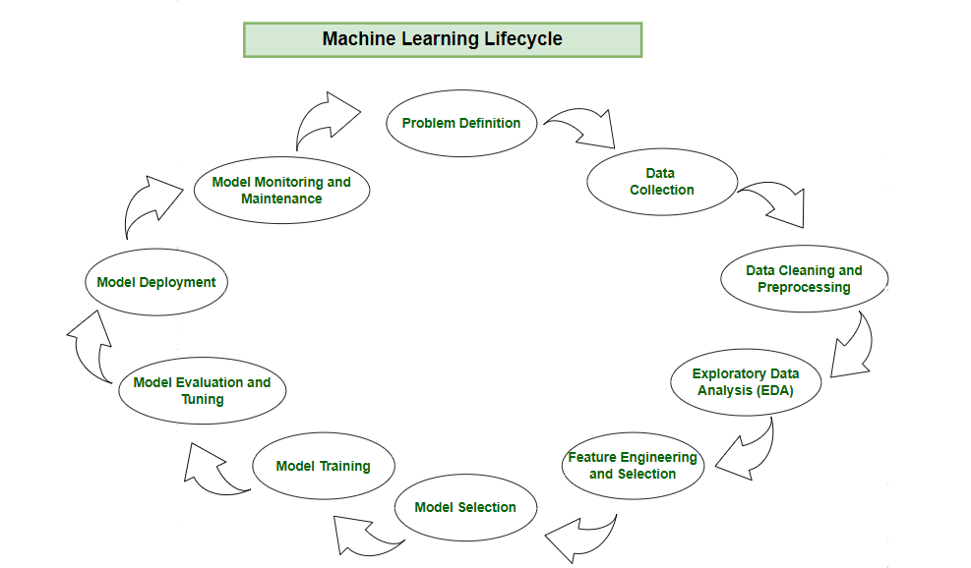
Machine Learning Lifecycle
Step 1: Problem Definition
In this initial phase we need to identify the business problem and frame it. By framing the problem in a comprehensive manner, team can establishes foundation for machine learning lifecycle. Crucial elements such as project objectives, desired outcomes and the scope of the task are carefully designed during this stage.
Here are some steps for problem definition:
- Collaboration: Work together with stakeholders to understand and define the business problem.
- Clarity: Clearly write down the objectives, desired outcomes and scope of the task.
- Foundation: Establish a solid foundation for the machine learning process by framing the problem comprehensively.

Step 2: Data Collection
After problem definition, machine learning lifecycle progresses to data collection. This phase involves systematic collection of datasets that can be used as raw data to train model. The quality and diversity of the data collected directly impact the robustness and generalization of the model.
During data collection we must consider the relevance of the data to the defined problem ensuring that the selected datasets consist all necessary features and characteristics. A well-organized approach for data collection helps in effective model training, evaluation and deployment ensuring that the resulting model is accurate and can be used for real world scenarios.
Here are some basic features of Data Collection:
- Relevance: Collect data should be relevant to the defined problem and include necessary features.
- Quality: Ensure data quality by considering factors like accuracy and ethical use.
- Quantity: Gather sufficient data volume to train a robust model.
- Diversity: Include diverse datasets to capture a broad range of scenarios and patterns.

Step 3: Data Cleaning and Preprocessing
With datasets in hand now we need to do data cleaning and preprocessing. Raw data is often messy and unstructured and if we use this data directly to train then it can lead to poor accuracy and capturing unnecessary relation in data, data cleaning involves addressing issues such as missing values, outliers and inconsistencies in data that could compromise the accuracy and reliability of the machine learning model.
Preprocessing is done by standardizing formats, scaling values and encoding categorical variables creating a consistent and well-organized dataset. The objective is to refine the raw data into a format that it is meaningful for analysis and training. By data cleaning and preprocessing we ensure that the model is trained on high-quality and reliable data.
Here are the basic features of Data Cleaning and Preprocessing:
- Data Cleaning: Address issues such as missing values, outliers and inconsistencies in the data.
- Data Preprocessing: Standardize formats, scale values, and encode categorical variables for consistency.
- Data Quality: Ensure that the data is well-organized and prepared for meaningful analysis.

Step 4: Exploratory Data Analysis (EDA)
To find patterns and characteristics hidden in the data Exploratory Data Analysis (EDA) is used to uncover insights and understand the dataset's structure. During EDA patterns, trends and insights are provided which may not be visible by naked eyes. This valuable insight can be used to make informed decision.
Visualizations helps in showing statistical summary in easy and understandable way. It also helps in making choices in feature engineering, model selection and other critical aspects.
Here are the basic features of Exploratory Data Analysis:
- Exploration: Use statistical and visual tools to explore patterns in data.
- Patterns and Trends: Identify underlying patterns, trends and potential challenges within the dataset.
- Insights: Gain valuable insights for informed decisions making in later stages.
- Decision Making: Use EDA for feature engineering and model selection.

Step 5: Feature Engineering and Selection
Feature engineering and selection is a transformative process that involve selecting only relevant features for model prediction. Feature selection refines pool of variables identifying the most relevant ones to enhance model efficiency and effectiveness.
Feature engineering involves selecting relevant features or creating new features by transforming existing ones for prediction. This creative process requires domain expertise and a deep understanding of the problem ensuring that the engineered features contribute meaningfully for model prediction. It helps accuracy while minimizing computational complexity.
Here are the basic features of Feature Engineering and Selection:
- Feature Engineering: Create new features or transform existing ones to capture better patterns and relationships.
- Feature Selection: Identify subset of features that most significantly impact the model's performance.
- Domain Expertise: Use domain knowledge to engineer features that contribute meaningfully for prediction.
- Optimization: Balance set of features for accuracy while minimizing computational complexity.

Step 6: Model Selection
For a good machine learning model, model selection is a very important part as we need to find model that aligns with our defined problem and the characteristics of the dataset. Model selection is a important decision that determines the algorithmic framework for prediction. The choice depends on the nature of the data, the complexity of the problem and the desired outcomes.
Here are the basic features of Model Selection:
- Alignment: Select a model that aligns with the defined problem and characteristics of the dataset.
- Complexity: Consider the complexity of the problem and the nature of the data when choosing a model.
- Decision Factors: Evaluate factors like performance, interpretability and scalability when selecting a model.
- Experimentation: Experiment with different models to find the best fit for the problem.

Step 7: Model Training
With the selected model the machine learning lifecycle moves to model training process. This process involves exposing model to historical data allowing it to learn patterns, relationships and dependencies within the dataset.
Model training is an iterative process where the algorithm adjusts its parameters to minimize errors and enhance predictive accuracy. During this phase the model fine-tunes itself for better understanding of data and optimizing its ability to make predictions. Rigorous training process ensure that the trained model works well with new unseen data for reliable predictions in real-world scenarios.
Here are the basic features of Model Training:
- Training Data: Expose the model to historical data to learn patterns, relationships and dependencies.
- Iterative Process: Train the model iteratively, adjusting parameters to minimize errors and enhance accuracy.
- Optimization: Fine-tune model to optimize its predictive capabilities.
- Validation: Rigorously train model to ensure accuracy to new unseen data.

Step 8: Model Evaluation and Tuning
Model evaluation involves rigorous testing against validation or test datasets to test accuracy of model on new unseen data. We can use technique like accuracy, precision, recall and F1 score to check model effectiveness.
Evaluation is critical to provide insights into the model's strengths and weaknesses. If the model fails to acheive desired performance levels we may need to tune model again and adjust its hyperparameters to enhance predictive accuracy. This iterative cycle of evaluation and tuning is crucial for achieving the desired level of model robustness and reliability.
Here are the basic features of Model Evaluation and Tuning:
- Evaluation Metrics: Use metrics like accuracy, precision, recall and F1 score to evaluate model performance.
- Strengths and Weaknesses: Identify the strengths and weaknesses of the model through rigorous testing.
- Iterative Improvement: Initiate model tuning to adjust hyperparameters and enhance predictive accuracy.
- Model Robustness: Iterative tuning to achieve desired levels of model robustness and reliability.

Step 9: Model Deployment
Upon successful evaluation machine learning model is ready for deployment for real-world application. Model deployment involves integrating the predictive model with existing systems allowing business to use this for informed decision-making.
Here are the basic features of Model Deployment:
- Integration: Integrate the trained model into existing systems or processes for real-world application.
- Decision Making: Use the model's predictions for informed decision.
- Practical Solutions: Deploy the model to transform theoretical insights into practical use that address business needs.
- Continuous Improvement: Monitor model performance and make adjustments as necessary to maintain effectiveness over time.
The Machine Learning lifecycle is a comprehensive and recursive process that involves multiple steps from problem definition to model deployment and maintenance. Each step is essential for building a successful machine learning model that can provide valuable insights and predictions. By following the Machine learning lifecycle organizations we can solve complex problems.

Q.2. Explain Linear regression along with an example.
Linear regression is a type of supervised machine-learning algorithm that learns from the labelled datasets and maps the data points with most optimized linear functions which can be used for prediction on new datasets. It assumes that there is a linear relationship between the input and output, meaning the output changes at a constant rate as the input changes. This relationship is represented by a straight line.
Linear regression is a statistical method used to model the relationship between a dependent variable and one or more independent variables by fitting a linear equation to observed data. The goal is to find the "best-fit" line that minimizes the sum of the squared differences between the observed values and the values predicted by the model.
Formula: For simple linear regression (one independent variable), the equation is typically represented as:
𝑌 = 𝑏0 + 𝑏1𝑋
Where:
𝑌 is the dependent variable (the variable being predicted).
𝑋 is the independent variable (the predictor variable).
𝑏0 is the y-intercept (the predicted value of Y when X is 0).
𝑏1 is the slope of the line (the change in Y for a one-unit change in X).
Example: Consider predicting a student's final exam score (dependent variable, Y) based on the number of hours they studied (independent variable, X).
Suppose you have the following data points:
Hours Studied (X) | Final Exam Score (Y)
2 | 60
4 | 75
6 | 85
8 | 95

Using linear regression, a line of best fit would be calculated to represent this relationship. Let's assume the calculated equation for this example is approximately:
𝐹 𝑖 𝑛 𝑎 𝑙 _ 𝐸 𝑥 𝑎 𝑚 _ 𝑆 𝑐 𝑜 𝑟 𝑒 = 50 + 5 × 𝐻 𝑜 𝑢 𝑟 𝑠 _ 𝑆 𝑡 𝑢 𝑑 𝑖 𝑒 𝑑
In this equation:
𝑏0 = 50 (If a student studied 0 hours, the predicted score is 50).
𝑏1 = 5 (For every additional hour studied, the predicted final exam score increases by 5 points).
This model can then be used to predict the final exam score for a student who studied, for example, 5 hours:
𝐹 𝑖 𝑛 𝑎 𝑙 _ 𝐸 𝑥 𝑎 𝑚 _ 𝑆 𝑐 𝑜 𝑟 𝑒 = 50 + 5 × 5 = 50 + 25
75 Therefore, the model predicts a final exam score of 75 for a student who studied 5 hours.

Q.3. Explain the terms overfitting, underfitting and bias variance tradeoff w.r.t Machine learning.
In machine learning, overfitting occurs when a model learns the training data too well, including noise, and performs poorly on new, unseen data. Underfitting happens when a model is too simple and cannot capture the underlying patterns in the data, resulting in poor performance on both training and new data. The bias-variance tradeoff describes the relationship between these two issues. A model with high bias is simple and underfits, while a model with high variance is complex and overfits. The goal is to find a balance (low bias and low variance) for optimal generalization to new data.
Overfitting:
- Definition: Overfitting occurs when a model learns the training data too precisely, including noise and random fluctuations, instead of the true underlying patterns.
- Characteristics: High accuracy on training data but poor accuracy on new data.
- Example: A model that perfectly predicts all data points in a training set, but fails to generalize to new, unseen data.
- Causes: Too complex model, insufficient training data, or noisy data.
Underfitting:
- Definition: Underfitting happens when the model is too simple to capture the underlying patterns in the data.
- Characteristics: Low accuracy on both training and new data.
- Example: Using a linear model to predict a non-linear relationship.
- Causes: Too simple model, insufficient training data, or inappropriate model selection.

Bias-Variance Tradeoff:
- Definition:
The bias-variance tradeoff highlights the relationship between a model's complexity and its ability to generalize.
- Bias:
Bias refers to the error introduced by approximating a real-world problem, which may be too complex, by a simplified model. High bias indicates the model is making strong assumptions about the data and may not be flexible enough to capture the true relationship.
- Variance:
Variance refers to the model's sensitivity to fluctuations in the training data. High variance indicates the model is overly sensitive to noise in the training data and may not generalize well to new data.
- Tradeoff:
A model with low bias (good fit to the training data) may have high variance (poor generalization). Conversely, a model with high bias (simple model) may have low variance (good generalization on simple data). The goal is to find a model with a good balance between bias and variance.
- Analogy:
Think of a target shooting. High bias would mean your shots consistently miss the bullseye but are clustered together (low variance). High variance would mean your shots are scattered all over the target, sometimes hitting the bullseye but with no consistency (high bias).
- Optimal Model:
The ideal model achieves a balance, minimizing both bias and variance, resulting in good performance on both training and new data.

Q.4. Create a Decision tree using Gini Index to classify following dataset for Profit.
